Bahria University,

Karachi Campus



COURSE: CSC-113 COMPUTER PROGRAMMING

TERM: FALL 2019, CLASS: BSE- 1 (B)

Submitted By:

M MUAZ SHAHZAD 02-131202-081

(Name) (Reg. No.)

Submitted To:

Engr. Adnan ur rehman/ Engr. Ramsha Mashood

Signed Remarks: Score:

INDEX

|  |  |  |  |  |
| --- | --- | --- | --- | --- |
| SNO | DATE | LAB NO | LAB OBJECTIVE | SIGN |
| 01 | 01-Dec-2020 | 09 | Arrays |  |
|  |  |  |  |  |
|  |  |  |  |  |
|  |  |  |  |  |
|  |  |  |  |  |
|  |  |  |  |  |
|  |  |  |  |  |
|  |  |  |  |  |
|  |  |  |  |  |
|  |  |  |  |  |
|  |  |  |  |  |
|  |  |  |  |  |
|  |  |  |  |  |
|  |  |  |  |  |
| SNO | DATE | LAB NO | LAB OBJECTIVE | SIGN |
|  |  |  |  |  |
|  |  |  |  |  |
|  |  |  |  |  |
|  |  |  |  |  |
|  |  |  |  |  |
|  |  |  |  |  |
|  |  |  |  |  |
|  |  |  |  |  |
|  |  |  |  |  |
|  |  |  |  |  |
|  |  |  |  |  |
|  |  |  |  |  |
|  |  |  |  |  |
|  |  |  |  |  |
|  |  |  |  |  |

Bahria University,

Karachi Campus



LAB EXPERIMENT NO.

**09**

LIST OF TASKS

|  |  |
| --- | --- |
| TASK NO | OBJECTIVE |
| 1 | Write a program, which creates an array of 20 elements of type integer and initializes each of the elements with a value equals to the index of the element multiplied by 5. Print the elements to the console. |
| **2** | Write a program, which reads two arrays from the console and checks whether they are equal (two arrays are equal when they are of equal length and all of their elements, which have the same index, are equal). |
| **3** | Make a program in C# in which take 5 numbers from user and then give sum and avg. of them. Using arrays. |
|  |  |
|  |  |
|  |  |
|  |  |
|  |  |
|  |  |

Submitted On:

01/12/2020

(Date: DD/MM/YY)

**Task No. 1: Write a program, which creates an array of 20 elements of type integer and initializes each of the elements with a value equals to the index of the element multiplied by 5. Print the elements to the console.**

**Solution:**namespace Cp_lab_task_1_array

{

class Program

{

static void Main(string[] args)

{

Console.WriteLine("Name: M Muaz Shahzad ");

Console.WriteLine("Enrollment Nó: 02-131202-081, BSE 1B");

int[] a = new int[20];

Console.ReadLine();

for (int k = 0; k < 20; k++)

{

a[k] = k * 5;

Console.WriteLine("Result : {0} ",a[k]);

}

Console.ReadLine();

}

}

}

**Output:**

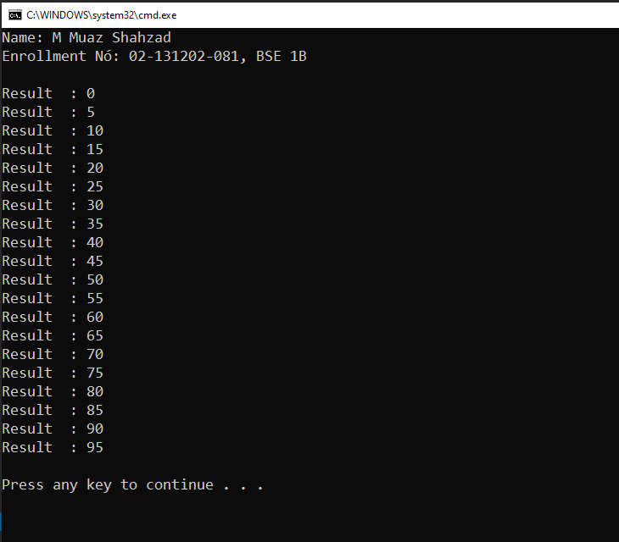

**Task No. 2: Write a program, which reads two arrays from the console and checks whether they are equal (two arrays are equal when they are of equal length and all of their elements, which have the same index, are equal).**

**Solution:**namespace Cp_lab_task_2_array_compare

{

class Program

{

static void Main(string[] args)

{

Console.Write("Enter A Num for 1st Array : ");

int m = int.Parse(Console.ReadLine());

int[] array1 = new int[m];

Console.Write("Enter A Num for 2nd Array : ");

int n = int.Parse(Console.ReadLine());

int[] array2 = new int[n];

Console.WriteLine("Enter The Elements For The First Arrray ");

for (int i = 0; i < m; i++)

{

Console.Write("Element - {0} : ", i);

array1[i] = int.Parse(Console.ReadLine());

}

Console.WriteLine("Enter The Elements For The Second Arrray ");

for (int j = 0; j < n; j++)

{

Console.Write("Element - {0} : ", j);

array2[j] = int.Parse(Console.ReadLine());

}

bool t = true;

if (array1.Length == array2.Length)

{

for (int i = 0; i < array1.Length; i++)

{

if (array1[i] != array2[i])

{

t = false;

break;

}

}

Console.WriteLine("Are Arrays equal? = {0} ", t);

Console.ReadLine();

}

else

{

Console.WriteLine("Arrays Length Are Not Equal ");

Console.ReadLine();

}

}

}

}

**Output:**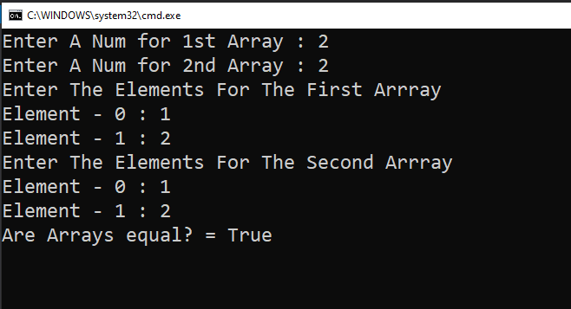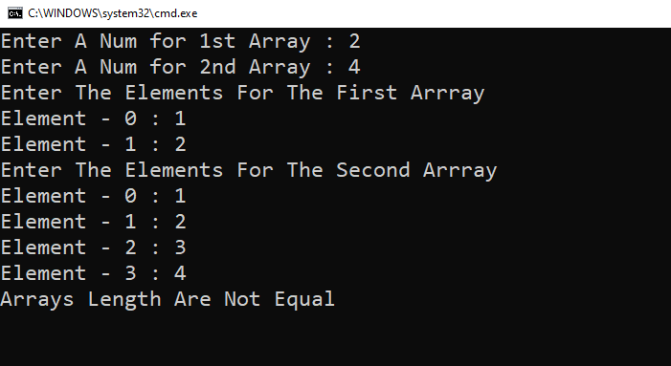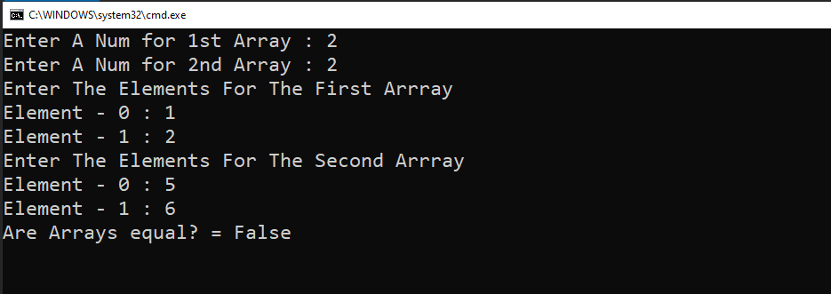

**Task No. 3: Make a program in C# in which take 5 numbers from user and then give sum and avg. of them. Using arrays.**

**Solution:**namespace cp_lab_array_task_3

{

class Program

{

static void Main(string[] args)

{

Console.Write("Enter a positive integer: ");

int n = int.Parse(Console.ReadLine());

int[] array = new int[n];

int avg = 0;

Console.WriteLine("Enter the values of the arrray ");

for (int i = 0; i < n; i++)

{

Console.Write("Element - {0} : ", i);

array[i] = int.Parse(Console.ReadLine());

}

int sum = 0;

for (int i = 0; i < n; i++)

{

sum += array[i];

}

avg = sum / n;

Console.WriteLine("Sum of all elements in the array is : {0}", sum);

Console.WriteLine("Avg is : {0}", avg);

Console.ReadLine();

}

}

}

**Output:**